25th International Conference “MECHANIKA 2021”

A Guide to Preparing Extended Abstracts “Mechanika 2021”

(Author’s) Name SURNAME*, Name SURNAME**, Name SURNAME***

* Affiliation, postal address, E-mail

** Affiliation, postal address, E-mail

General guidelines
Extended abstracts should be written according to the below structure and formatted so that it is consistent with the Mechanika conference’s Full Paper Template.
A structure with the following headings is recommended: keywords, introduction, methods, findings and argument, conclusion and recommendations. There is flexibility as to the naming of the sections. Sub-headings can be used when necessary.
Extended abstracts can contain figures, tables and/or images. Page format should be consistent with the Mechanika conference’s Full Paper Template. Extended abstracts should not exceed 2 pages including any references.
The introduction section should present the scope and objective of the paper and state the problem; briefly review the pertinent literature; describe the methods, and provide an overview of the main results of the work.
The methodology must be clearly stated and described in sufficient detail or with sufficient references.
The findings and arguments of the work should be explicitly described and illustrated. Supporting figures, tables and images of the results (no more than two figures and two tables) may be included in the extended abstract.
Conclusions should include the principles and generalisations inferred from the results; any exceptions to, or problems with these principles and generalisations; theoretical and/or practical implications of the work, and conclusions drawn and recommendations.

1. Layout

Extended abstract should be typed with single spacing using Microsoft Word processor (preferably). Times New Roman font should be used. The text should be typed in two columns on A4 format sheets (210 x 297 mm); spacing between columns should be 6 mm. Leave 20 mm margins at the top, 17 mm at the bottom, 18 mm left and at right sides.
The title of an article should be printed in 16 pt (Bold), author's name – 12 pt (Bold), title of the institution – 10 pt (Italic), headings of the chapters – 10 pt (Bold), the body text and summary – 10 pt, indexes – 8 pt, text of the tables – 9 pt, formulae in the text (using Math Type 6.0) – 10 pt, indexes – 6 pt, subindexes – 5pt (all symbols – Italic, vectors – Bold, numbers – Normal). Fig. 2 how to define fonts in formulae. Italic characters should be used for symbols from the figures and graphs mentioned in the text.
New paragraph must be indented in the first line by 1.27 cm. Line spacing – Single.
References should be numbered consecutively (numerals in square brackets) through the text and collected together in a reference list at the end of the paper. Please place the references according to their order of appearance in the text. Use 10 pt, regular for the reference list. The authors shall be typed in Bold, name of the article – Normal.

3. Figures and tables
The figures and tables shall be numbered, have a self-contained caption. Figure captions shall be below the figures; table captions shall be above the tables. Please avoid placing figures and tables before their first mention in the text.
The text of figure captions shall be 10 pt high, Times New Roman and Normal. For the words Fig. and Table use Normal. Name of the Figure should be made with Hanging of 0.95 cm. Name of the Table shall be made with After spacing of 5 pt.
All the figures, graphs and photographs shall be numbered and referred in the main text. Abscissas and ordinates of all graphs shall be labelled with symbols and units.
All figures, graphs and photographs can be in colours as well as in black and white (or grey shades).
Figures, tables shall be arranged in such a way that they would fit into one (84 mm width) or two columns (only in the start or end of the page).
Fig. 1 General view of a specimen with side grooves
One-line spacing shall separate the figures and tables from the text.

4. Formulaes
All equations and symbols in the text shall be written in Math Type 6.0. Formulae styles and sizes you can define as it is show in Fig. 2 and Appendix. The example how to type formulae inside two columns is presented below (1):
, (1)
where: spacing before – 10 pt, spacing after – 10 pt, Tab stop positions are 0.75 cm and 8.4 cm, respectively.

Table 1
Mechanical characteristics of pipes main steel, weld and heat affected zone metal
Pipeline index | Pipe steel, weld and heat affected zone (HAZ) metal | Test temperature T, ºC | Yield stress , MPa | Ultimate stress  , MPa | Poisson’s ratio  ν | Young’s modulus  E, MPa
DU-300 | Steel 08X18N10T | 20 | 309 | 608 | 0.35 | 140300
 |  | 285 | 232 | 397 | 0.35 | 140100
 | Heat affected zone (HAZ) metal | 20 | 283 | 584 | 0.35 | 151500
 |  | 285 | 240 | 474 | 0.35 | 188800
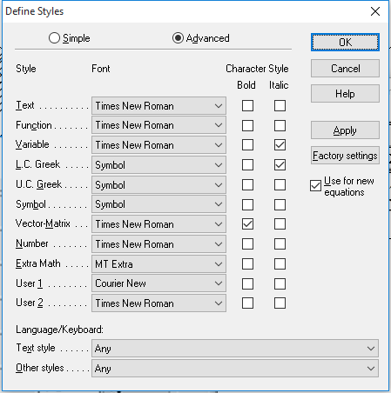
a
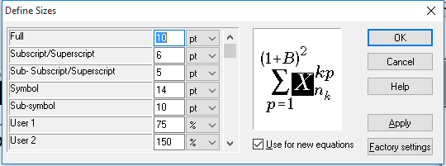
b
Fig. 2 Define of formulae: a – styles, b – sizes

The example how to type formulae inside one column is presented in (2):
. (2)

For this case spacing before – 10 pt, spacing after – 10 pt, Tab stop positions are 8.7 cm and 17.4 cm, respectively.

4. Conclusions
We thank you in advance for the usage carefully of instructions for camera-ready articles, which can be sent for publication with minor modification. The example of article published in Mechanika is available on Website http://www.mechanika.ktu.lt.

References
- Standard Test Method for Determining J-R Curves. ASTM E1152-87. 11 p.
- Jonaitis M.; Kamaitis P.; Rimaitis E. 1999. Determining J-R curves of steam pipeline Du-630 welded joint materials in Ignalina NPP, Mechaninė technologija t. XXVII: 182-199 (in Russian).
http://dx.doi.org/XX.XXX/(XXX)XX-XX(XXX)X:X.
- Anderson, T. L. 1991. Fracture Mechanics. Fundamentals and Applications.-Boca Raton, Ana Arbor: CRC Press. 793 p.
- Dickey, H.; Watson, V.; Zangelidis, A. 2009. Job satisfaction and quit intentions of offshore workers in the UK North Sea oil and gas industry [online] MPRA [accessed 9 Febr. 2010]. Available from Internet: http://mpra.ub.unimuenchen. de/18666/.
Keywords: this section shall contain maximum 5 words written in lower case separated by commas.

