A Guide to Preparing Manuscript for International Scientific Conference Mechanika 2024

(Author’s) Name SURNAME¹*, Name SURNAME², Name SURNAME^{1,3}

1 Affiliation, city, country

2 Affiliation, city, country

3 Affiliation, city, country

* e-mail@domain.com; website (optional) (* please mark the corresponding author with an asterisk)
Abstract
Manuscript should be written according to the below structure and formatted so that it is consistent with the Mechanika conference’s Full Paper Template.
A structure with the following headings is recommended: abstract, keywords, introduction, methods, findings and arguments and conclusions. There is flexibility as to the naming of the sections. Sub-headings can be used when necessary.
The length of a manuscript not limited but it should not exceed 4 – 6 pages including figures, references and abstract. Not less than 75 % – 80 % the last page should be filled.
The introduction section should present the scope and objective of the paper and state the problem; briefly review the pertinent literature; describe the methods, and provide an overview of the main results of the work.
The methodology must be clearly stated and described in sufficient detail or with sufficient references.
The findings and arguments of the work should be explicitly described and illustrated. Supporting figures, tables and images of the results (no more than two figures and two tables) may be included in the manuscript.
Conclusions should include the principles and generalisations inferred from the results; any exceptions to, or problems with these principles and generalisations; theoretical and/or practical implications of the work, and conclusions drawn and recommendations.

Keywords: this section shall contain maximum 5 words written in lower case separated by commas.
1. Layout
Extended abstract should be typed with single spacing using Microsoft Word processor (preferably). Times New Roman font should be used. The text should be typed in one column on A4 format sheets (210 x 297 mm). Leave 20 mm margins at the top, 17 mm at the bottom, 18 mm left and at right sides.
The title of an article should be printed in 16 pt (Bold) {styles – Heading 2}, author's name – 12 pt (Bold) {styles – Heading 3}, title of the institution – 10 pt (Italic) {styles – Heading 4}, headings of the chapters – 10 pt (Bold) {styles – Chapter Title }, the body text and abstract – 10 pt {styles – Normal}, table title – 10 pt {styles – Table title}, text of the tables – 9 pt {styles – Table text}, figure title – 10 pt {styles – Fig. title}, formulas in the text (using Math Type 6.0) – 10 pt {styles – Formula}, indexes – 6 pt, subindexes – 5pt (all symbols – Italic, vectors – Bold, numbers – Normal). Fig. 2 shows how to define fonts in formulas. Italic characters should be used for symbols from the figures and graphs mentioned in the text, list of references – 10 pt {styles – References list}.
New paragraph must be indented in the first line by 0.5 cm. Line spacing – Single.
References should be numbered consecutively (numbers in square brackets) through the text and collected together in a reference list at the end of the paper. Please place the references according to their order of appearance in the text like here [1]. Use 10 pt, regular for the reference list. The authors shall be typed in Bold, name of the article – Normal.
2. Figures and tables
The figures and tables shall be numbered, have a self-contained caption. Figure captions shall be below the figures (Fig.1); table captions shall be above the tables (Table 1). Please avoid placing figures and tables before their first mention in the text.
The text of figure captions shall be 10 pt high, Times New Roman and Normal. Name of the Figure should be centred.

Fig. 1 General view of a specimen with side grooves [2]

All the figures, graphs and photographs shall be numbered and referred in the main text. Abscissas and ordinates of all graphs shall be labelled with symbols and units.
All figures, graphs and photographs can be in colours as well as in black and white (or grey shades).
One-line spacing shall separate the figures and tables from the text.
3. Formulas
All equations and symbols in the text shall be written in Math Type 6.0. Formulas styles and sizes you can define as it is show in Fig. 2 and Appendix. The example how to type formulas inside two columns is presented below (1):
, (1)
where: spacing before – 10 pt, spacing after – 10 pt, Tab stop positions are 8.7 cm and 17.4 cm, respectively.

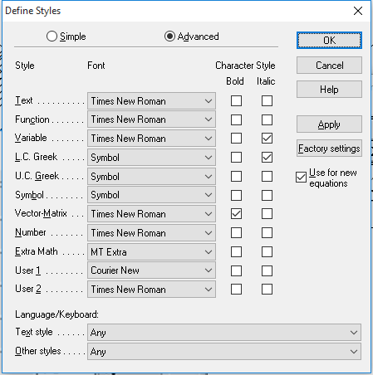
(a)
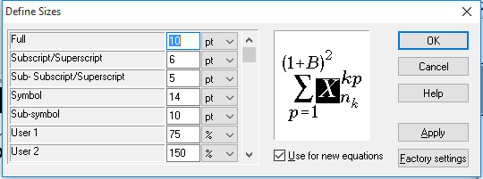
(b)
Fig. 2 Define of formulas: (a) styles, (b) sizes

Table 1. Mechanical characteristics of pipes main steel, weld and heat affected zone metal
Pipeline index | Pipe steel, weld and heat affected zone (HAZ) metal | Test temperature T, ºC | Yield stress , MPa | Ultimate stress  , MPa | Poisson’s ratio, ν | Young’s modulus  E, MPa
DU-300 | Steel 08X18N10T | 20 | 309 | 608 | 0.35 | 140300
 |  | 285 | 232 | 397 | 0.35 | 140100
 | Heat affected zone (HAZ) metal | 20 | 283 | 584 | 0.35 | 151500
 |  | 285 | 240 | 474 | 0.35 | 188800
4. Conclusions
We thank you in advance for the usage carefully of instructions for camera-ready articles, which can be sent for publication with minor modification.
References
- Janusas, G.; Ponelyte, S.; Brunius, A.; Guobiene, A.; Prosycevas, I.; Vilkauskas, A.; Palevicius, A. Periodical microstructures based on novel piezoelectric material for biomedical applications. Sensors 2015, 15(12), 31699–31708.
- Hibbeler, R. Engineering mechanics: Statics, 14th ed., Publisher: Pearson, 2015, 740 p.
- Dickey, H.; Watson, V.; Zangelidis, A. Job satisfaction and quit intentions of offshore workers in the UK North Sea oil and gas industry [online]. Munich Personal RePEc Archive 2009 [accessed 31 January 2023]. Available online: http://mpra.ub.unimuenchen.de/18666/.
- Barauskiene, R.; Barauskas, R., Daniulaitis, V. Implementation of finite element distance learning and research tools by using web services. Information Technologies’ 2009: proceedings of the 15th International Conference on Information and Software Technologies, 2009, 301-307.

